Insert Data into db:

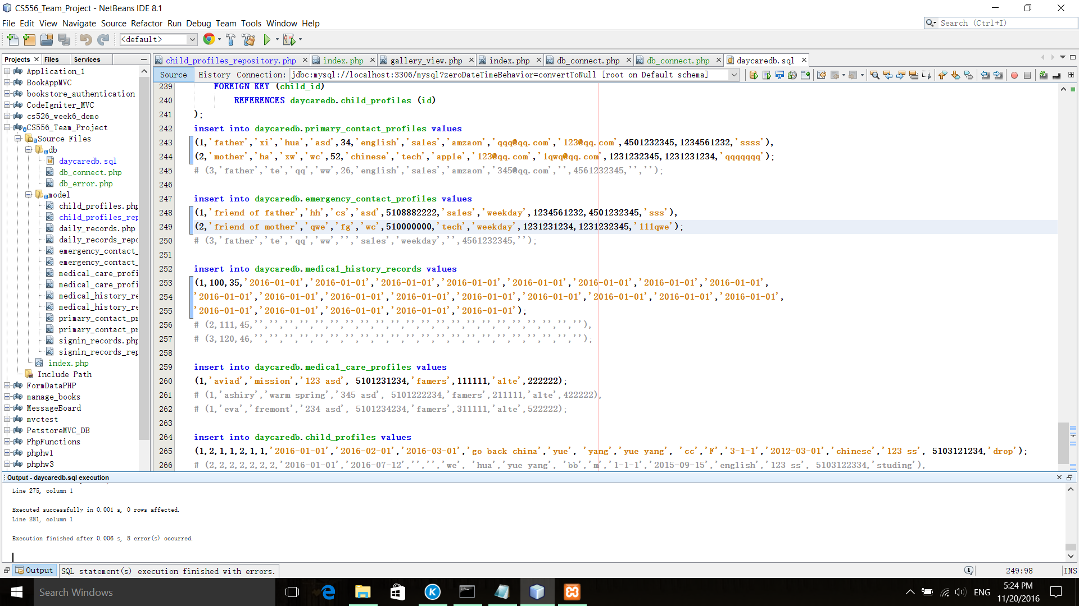

Test ChildProfilesRepository::getChilds()

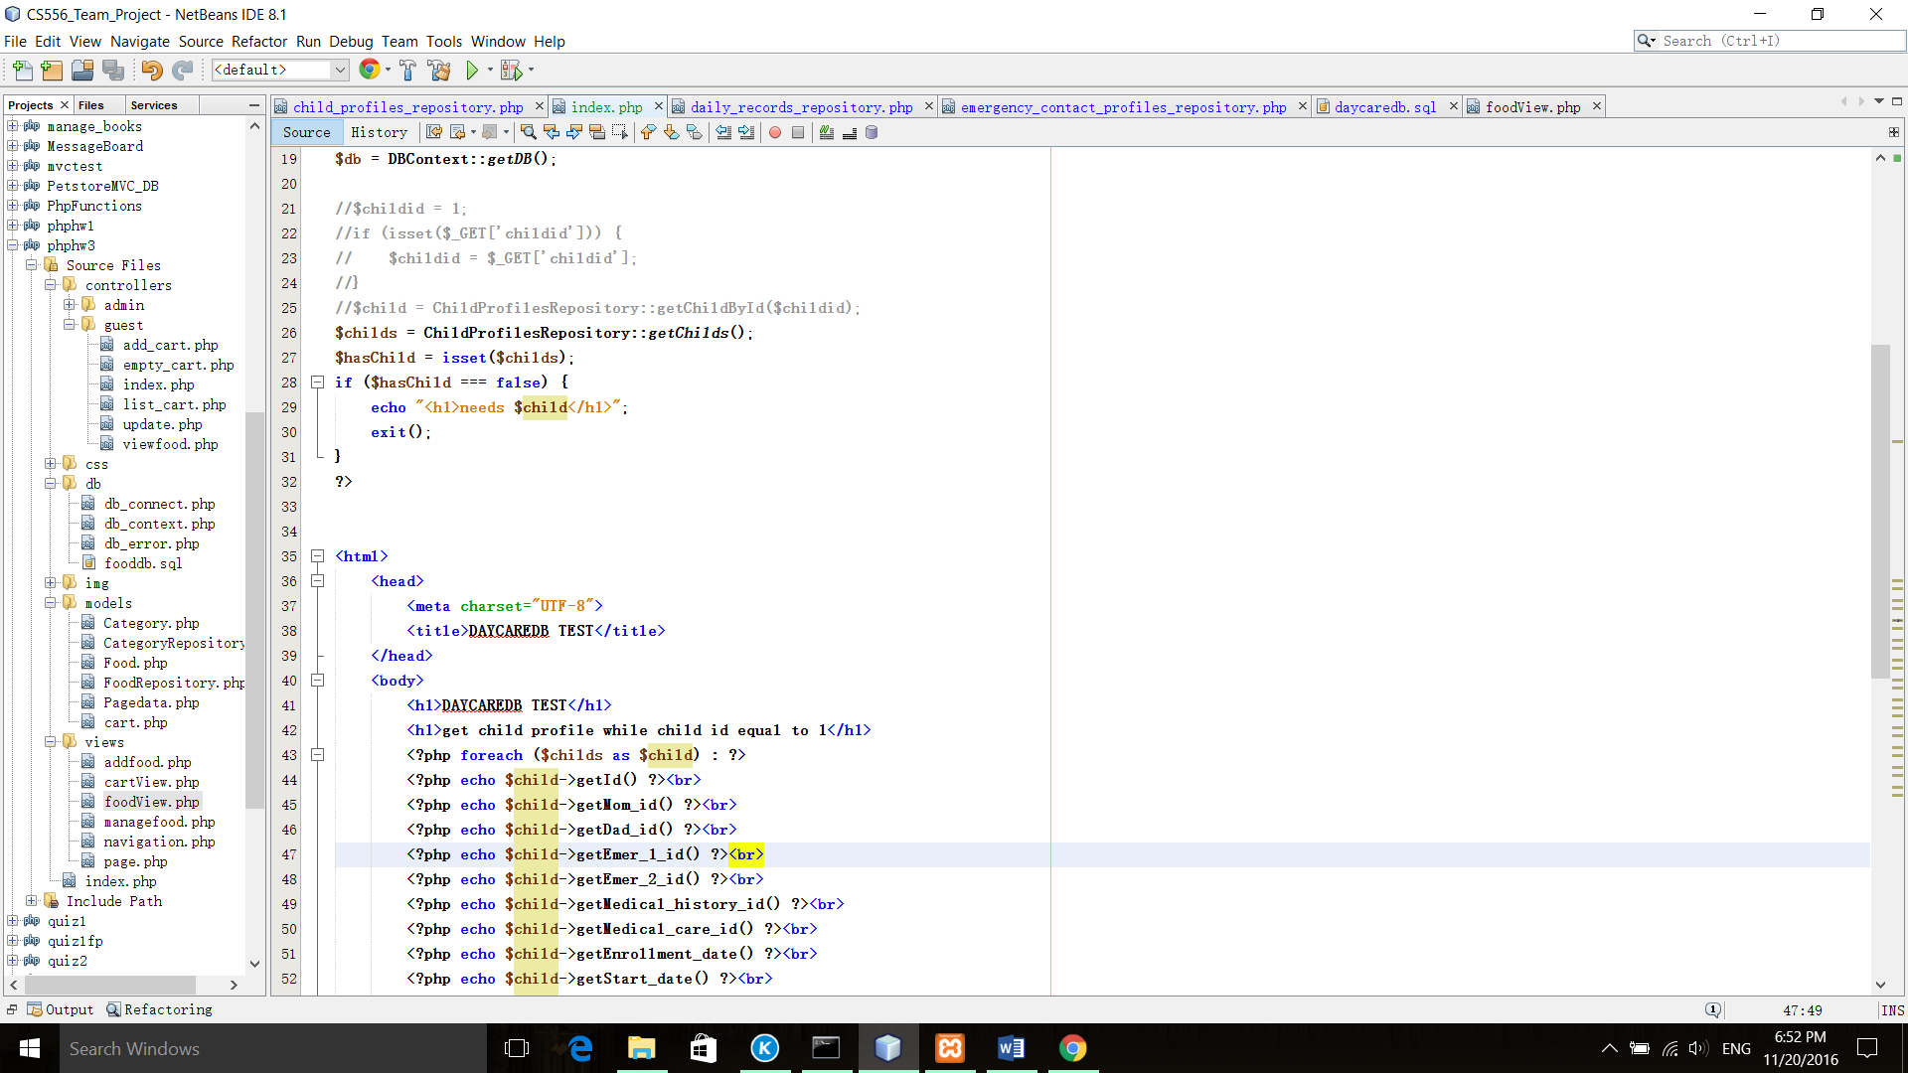

Test ChildProfilesRepository::getChildById($childId)

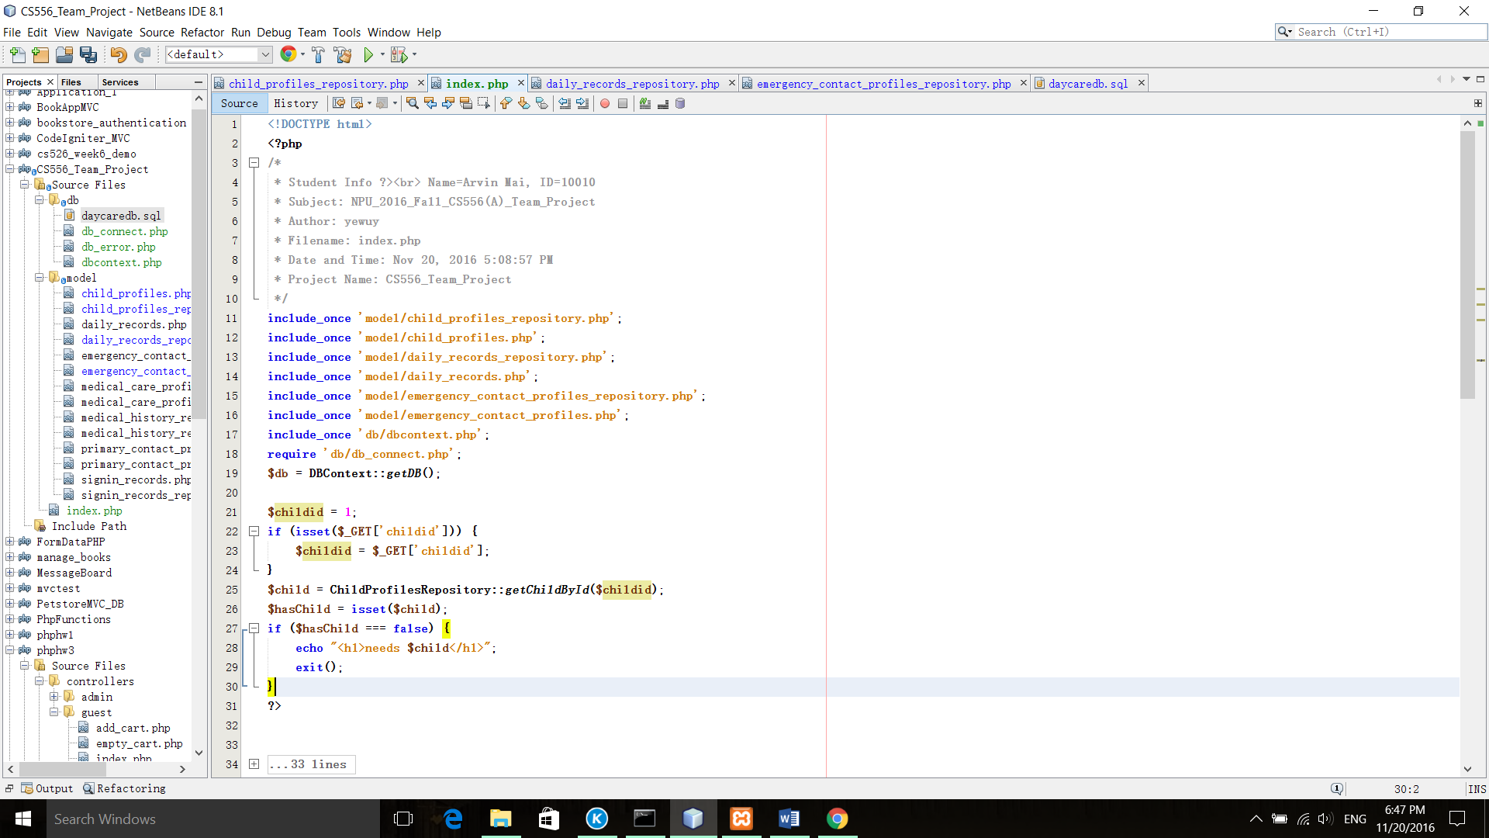

Test ChildProfilesRepository::getChildsByName($fname, $lname)

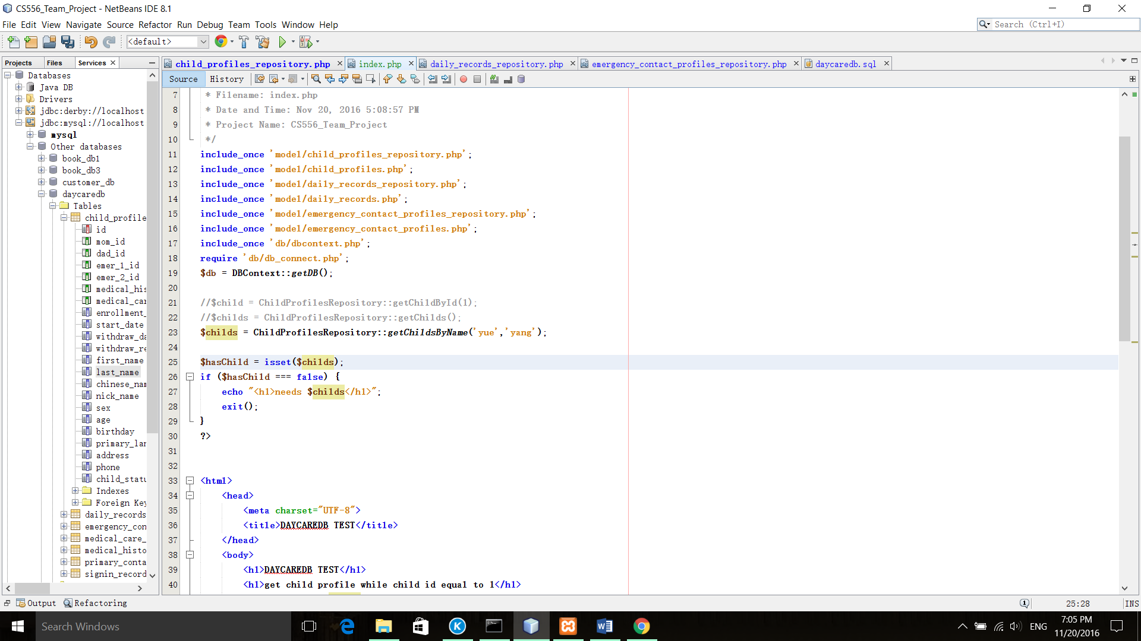

Test ChildProfilesRepository::getChildsByChineseName($name)

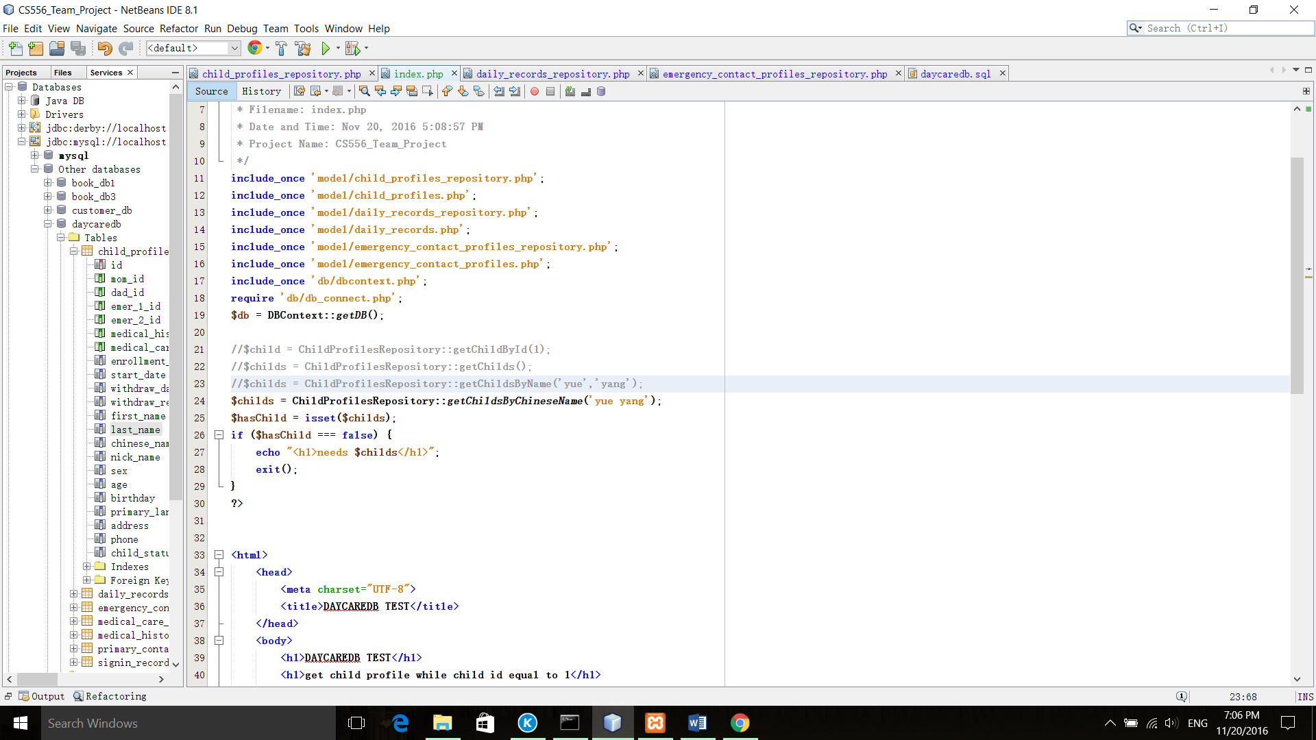

Test ChildProfilesRepository::getChildsByPhone($phone)

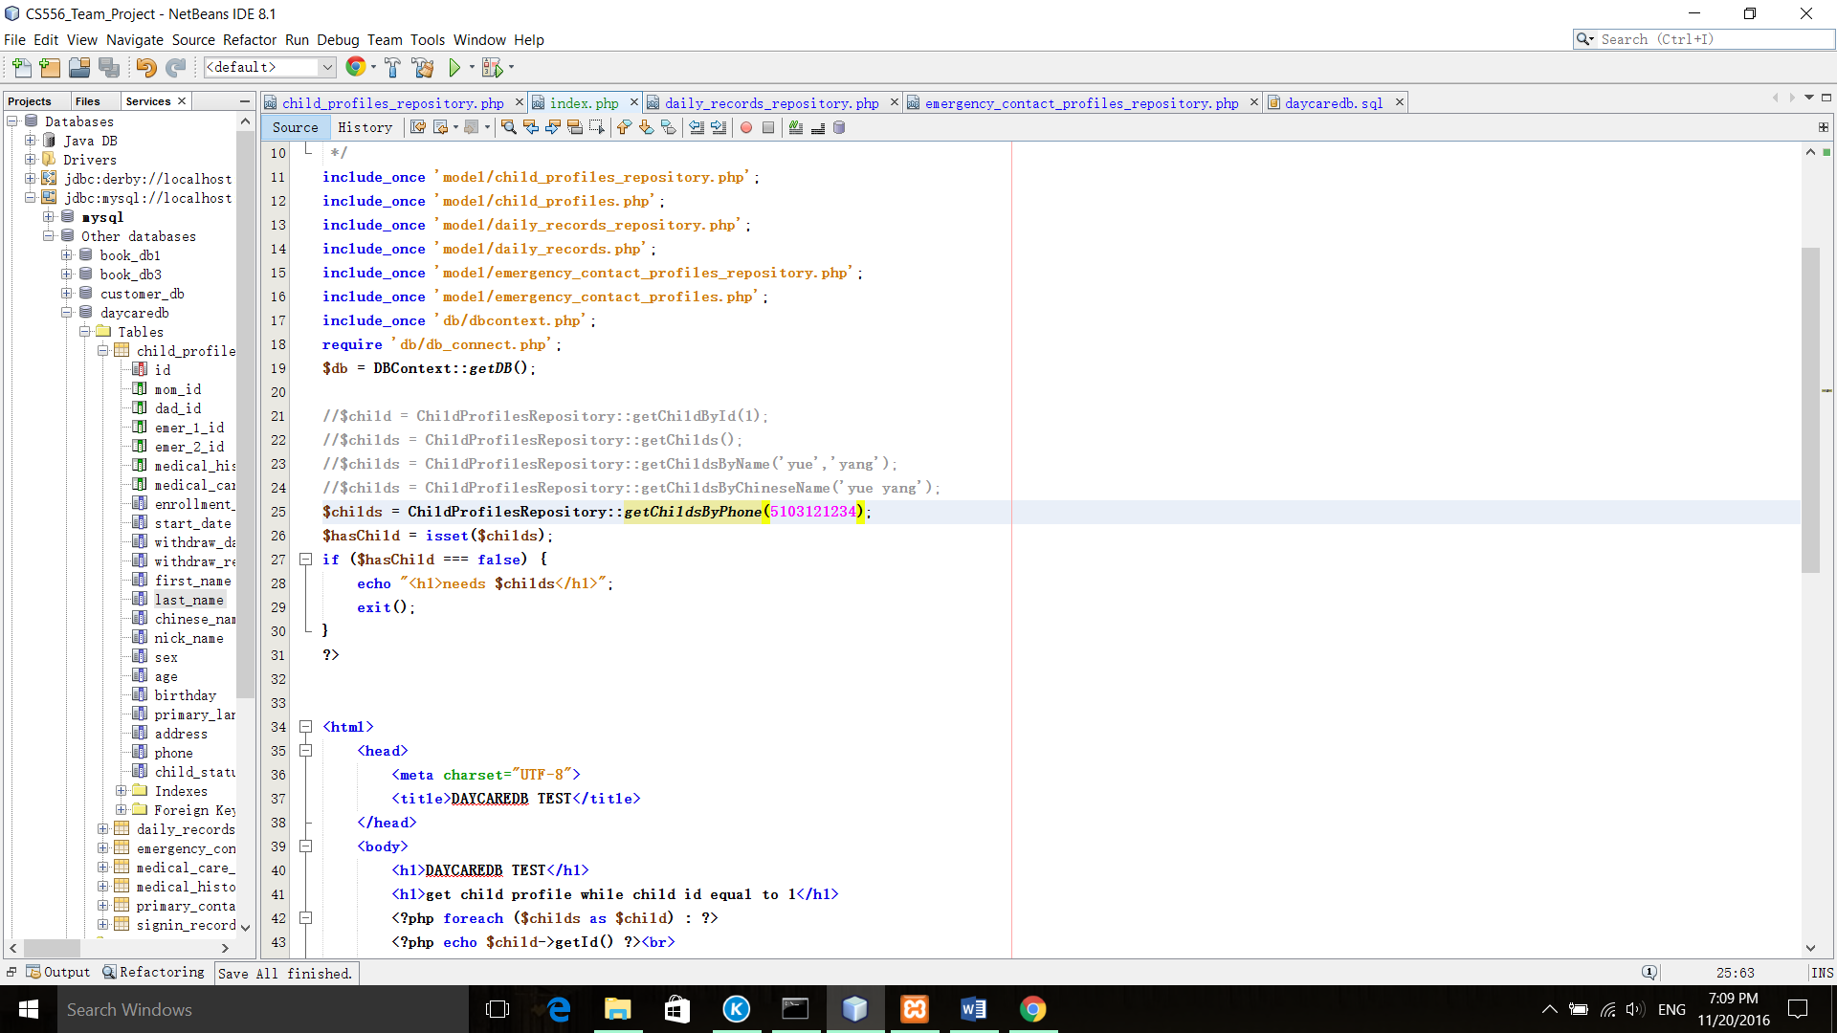

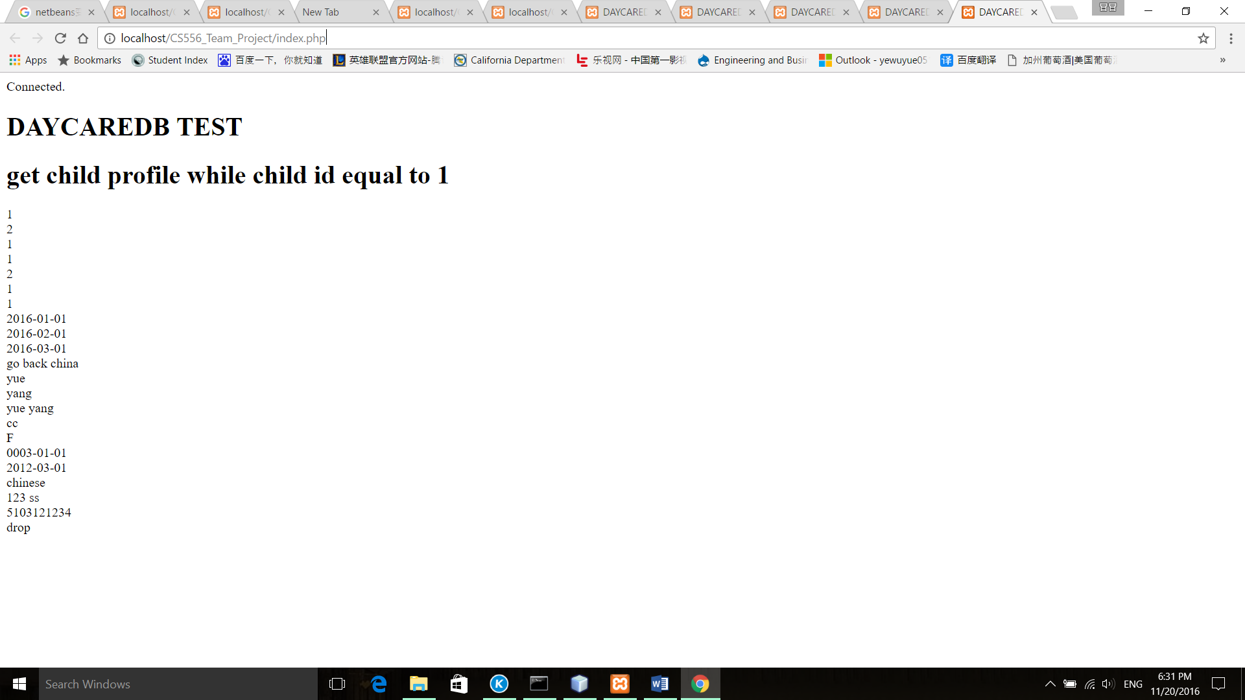

Test ChildProfilesRepository::deleteChild($childid);

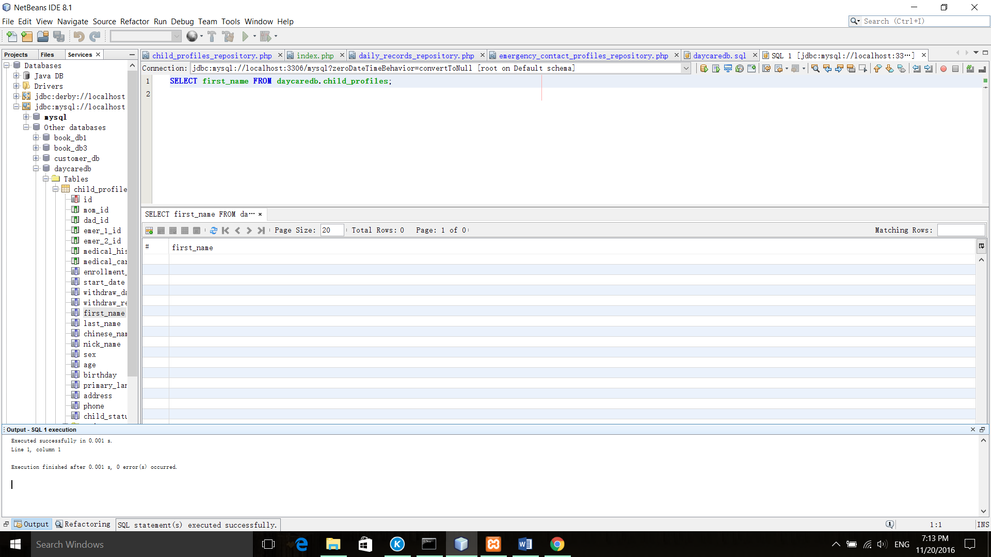

Test ChildProfilesRepository::addChild($child)

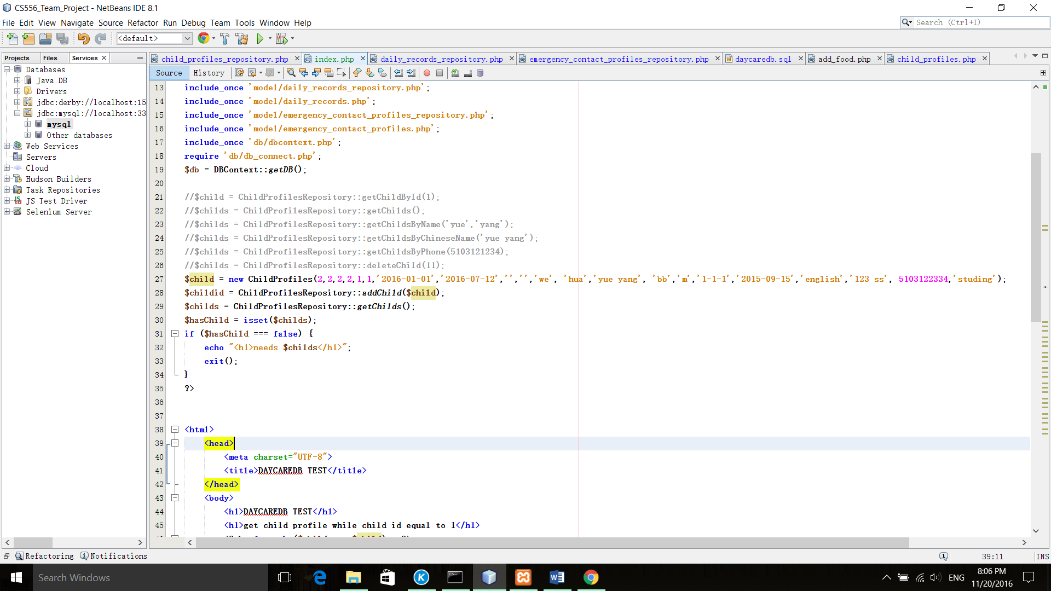

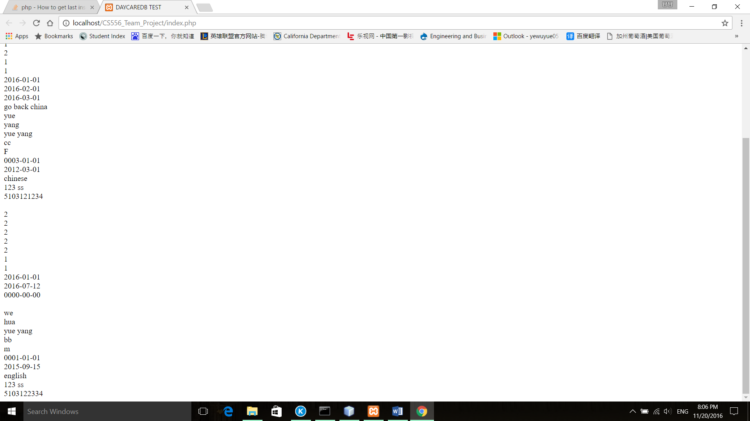

Test DailyRecordsRepository::getDailyRecords()

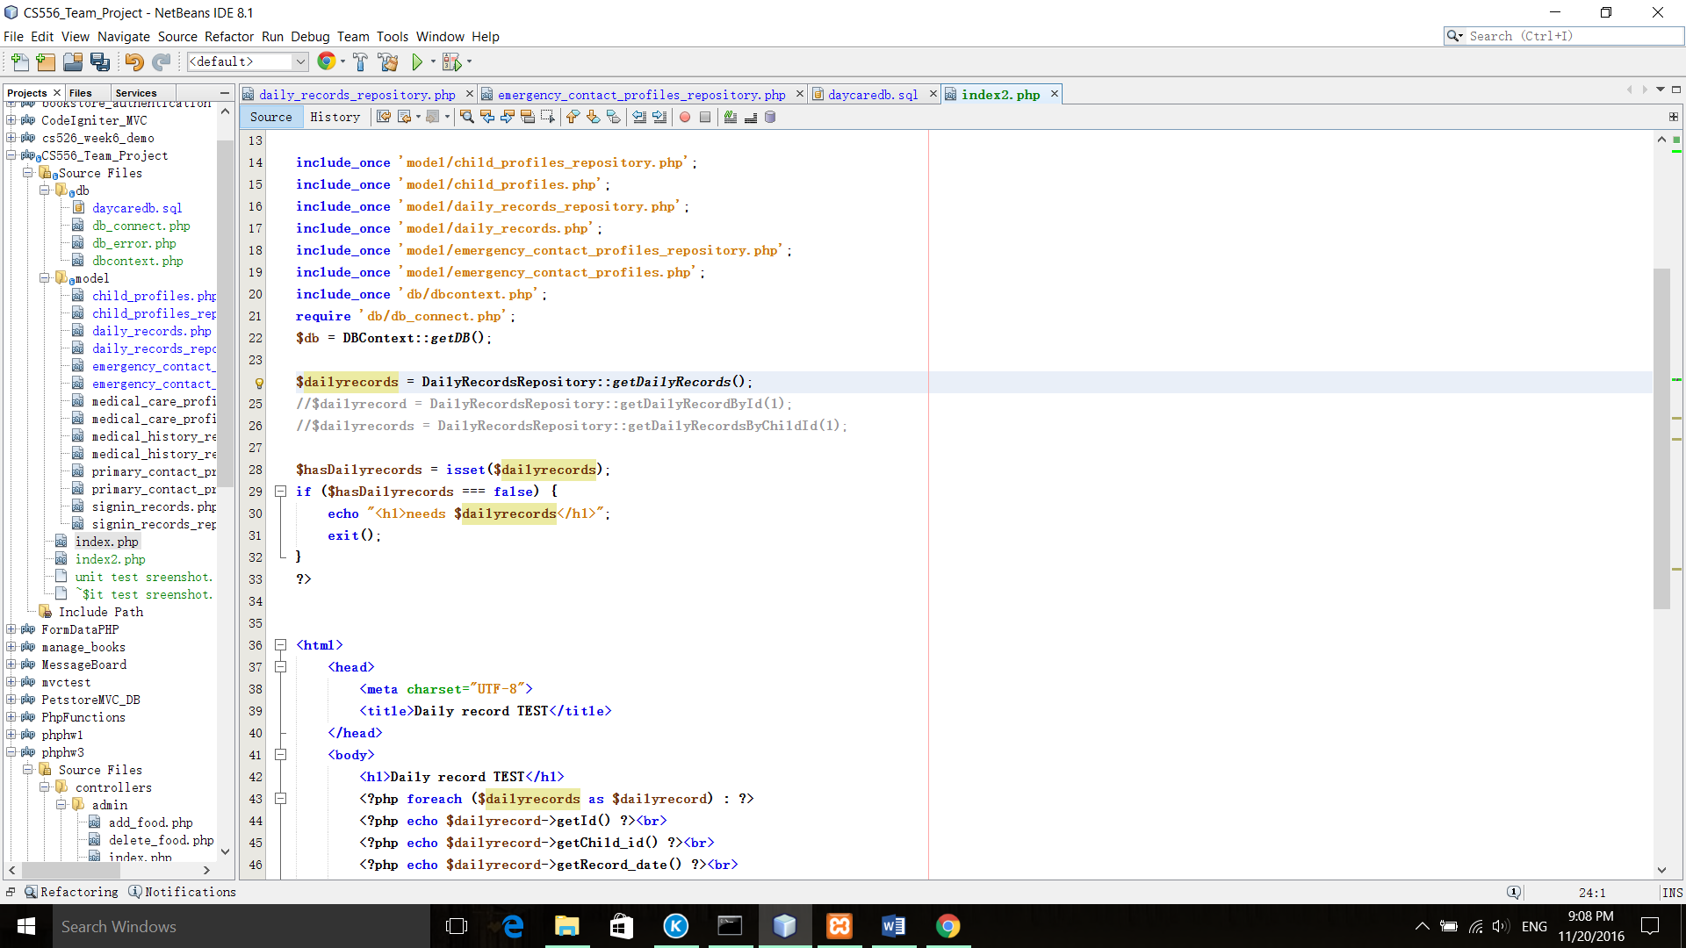

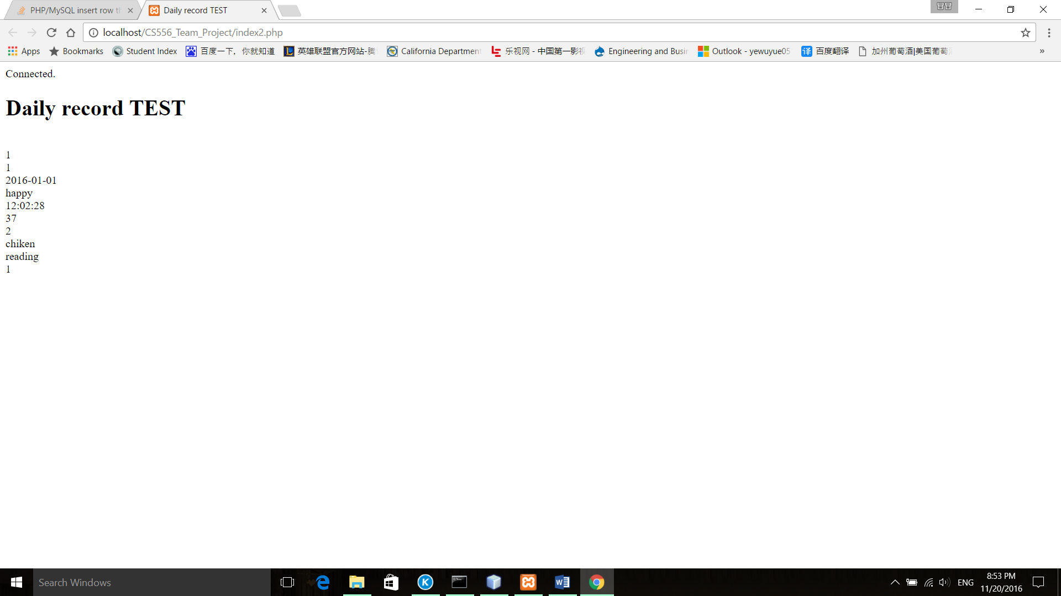

DailyRecordsRepository::getDailyRecordById($id)

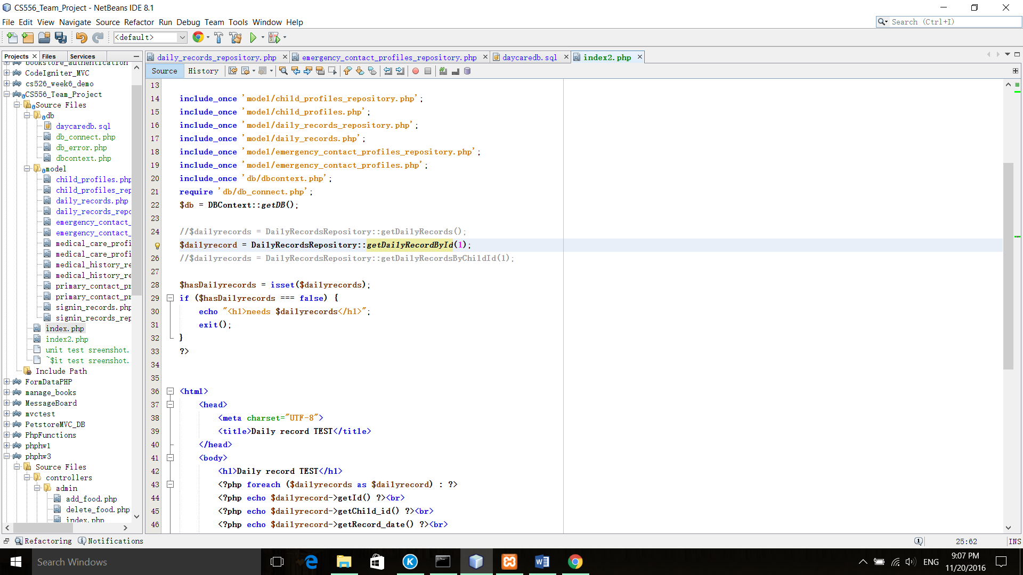

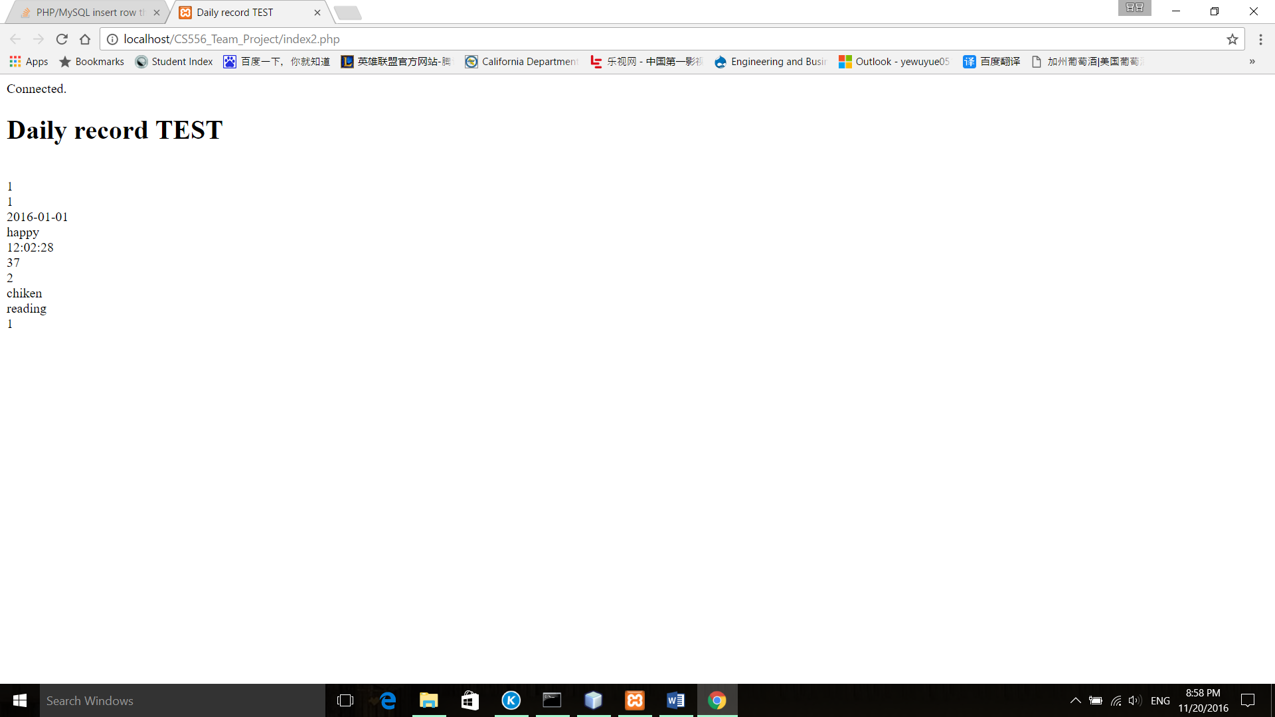

DailyRecordsRepository::getDailyRecordsByChildId($childId)

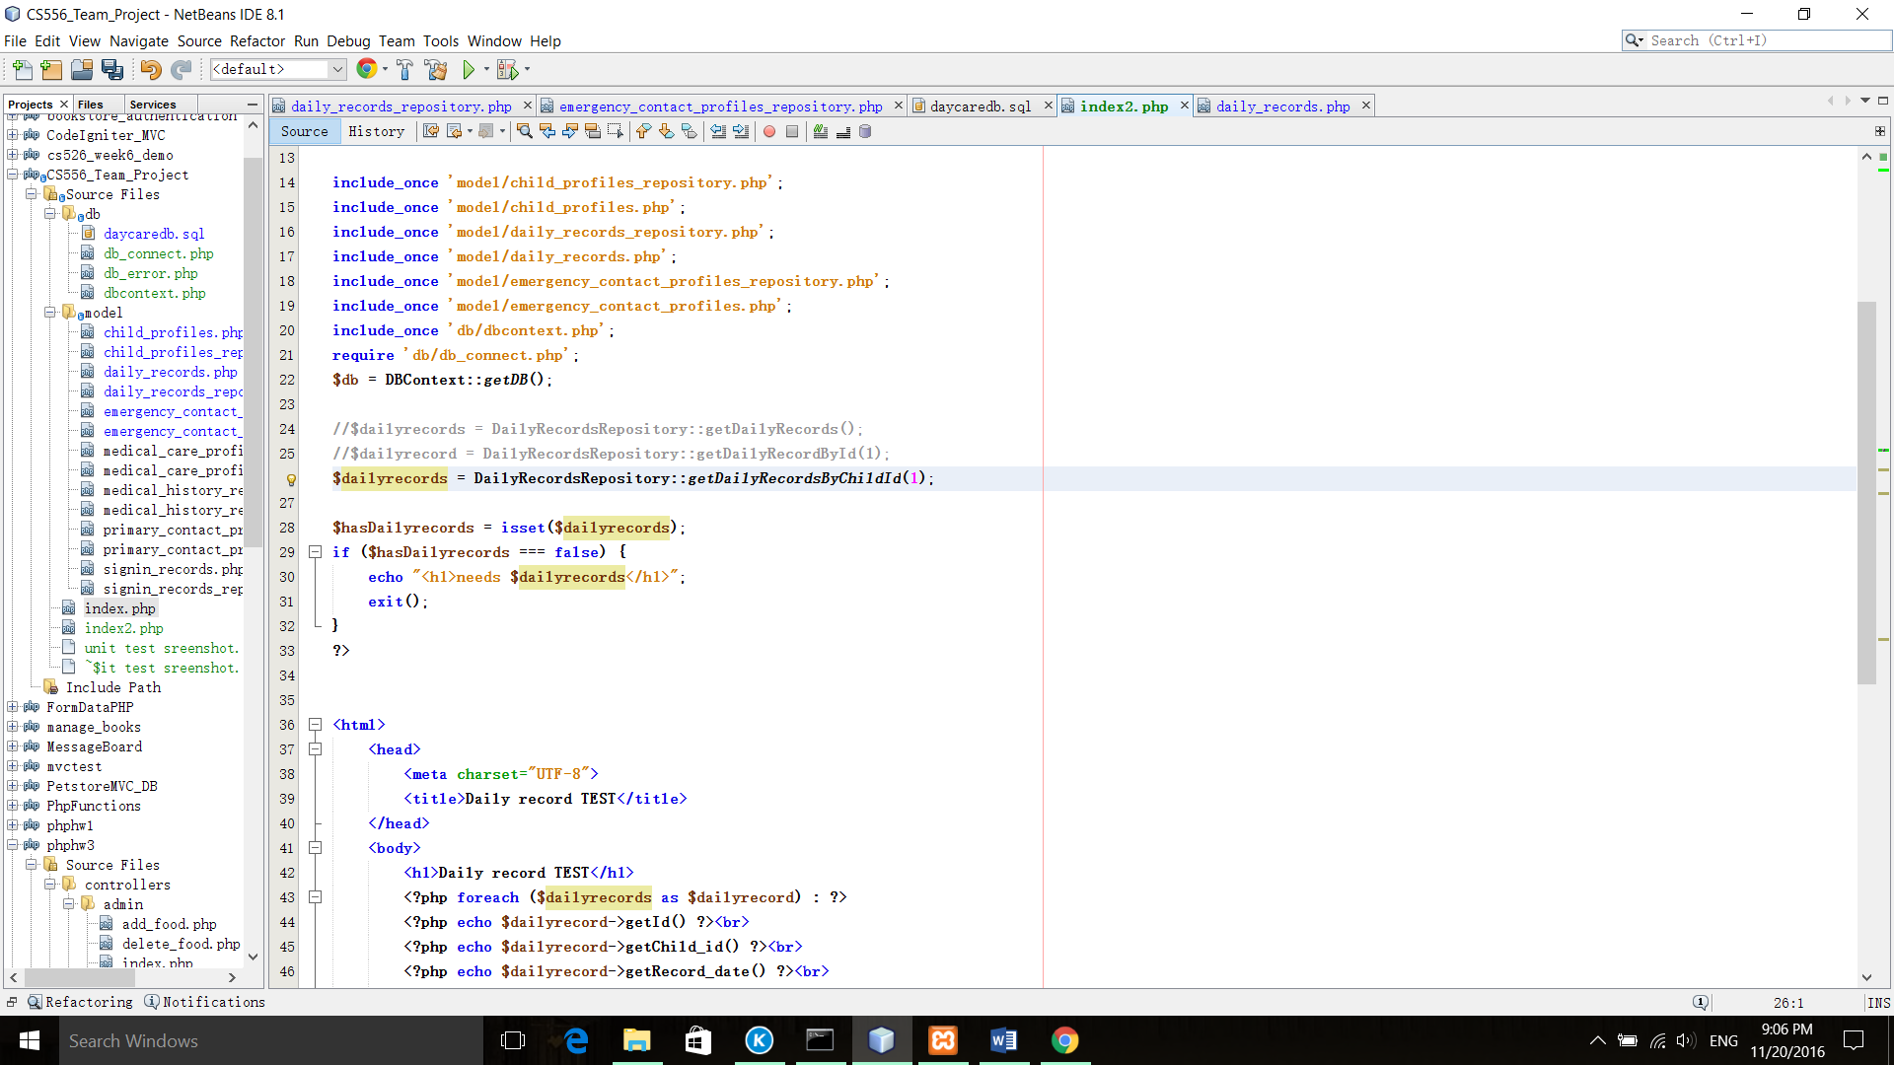

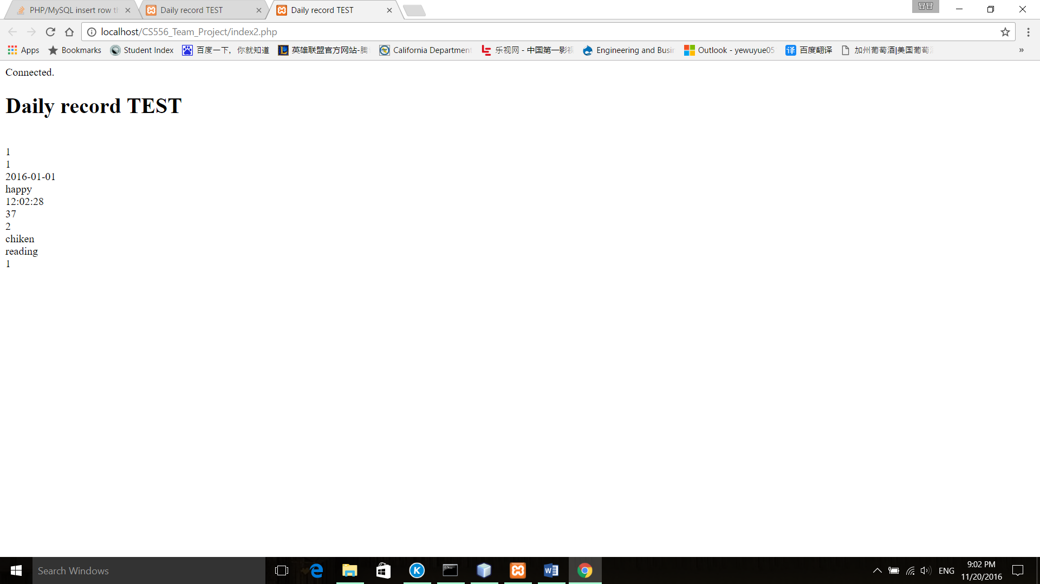

Test DailyRecordsRepository::addDailyRecord($dailyRecord)

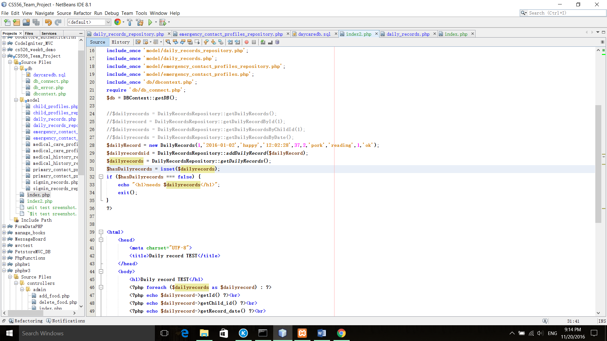

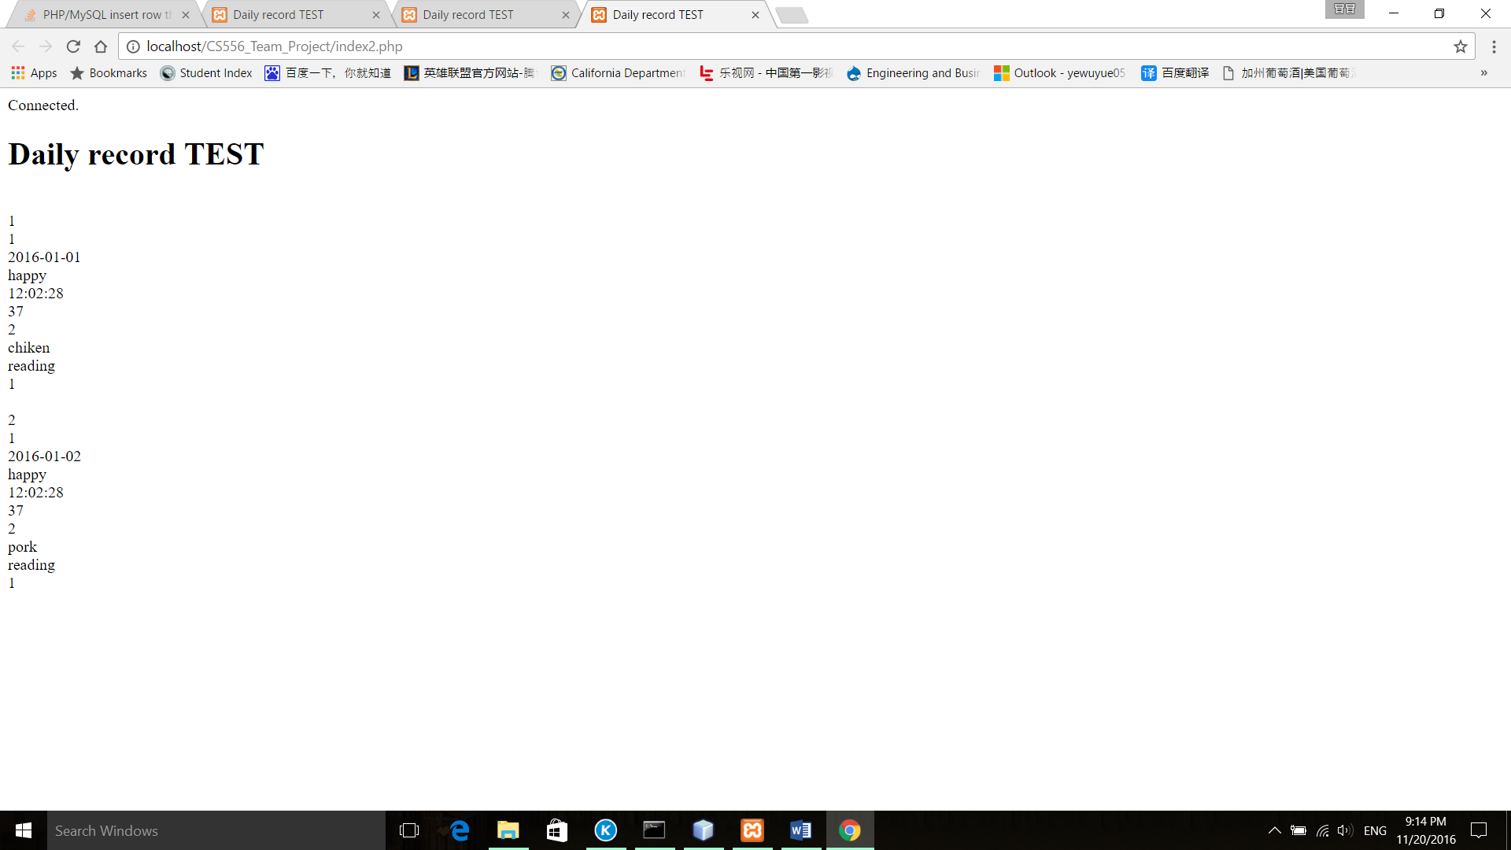

Test DailyRecordsRepository::getDailyRecordsByDate($initialDate, $finalDate = NULL);

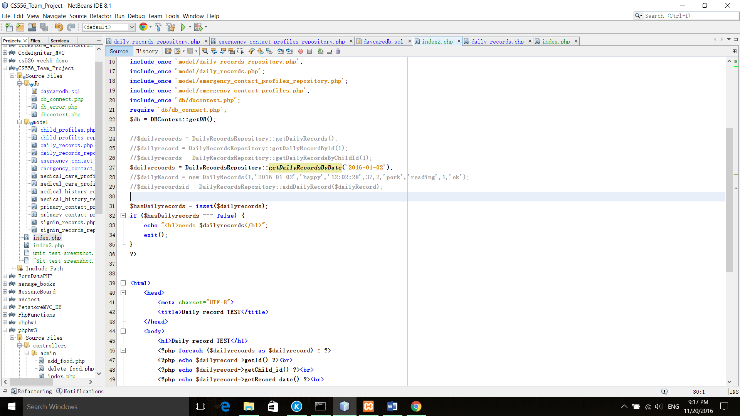

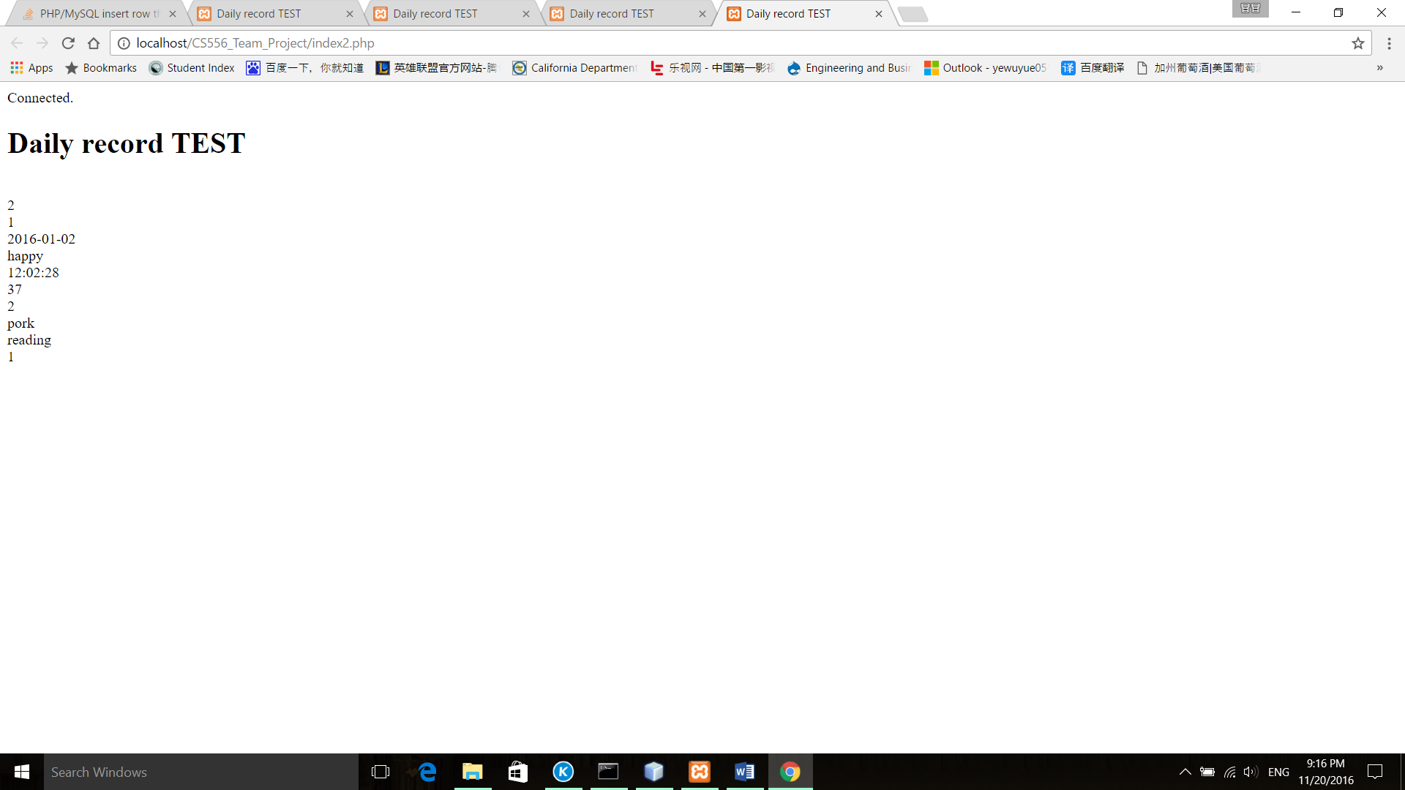

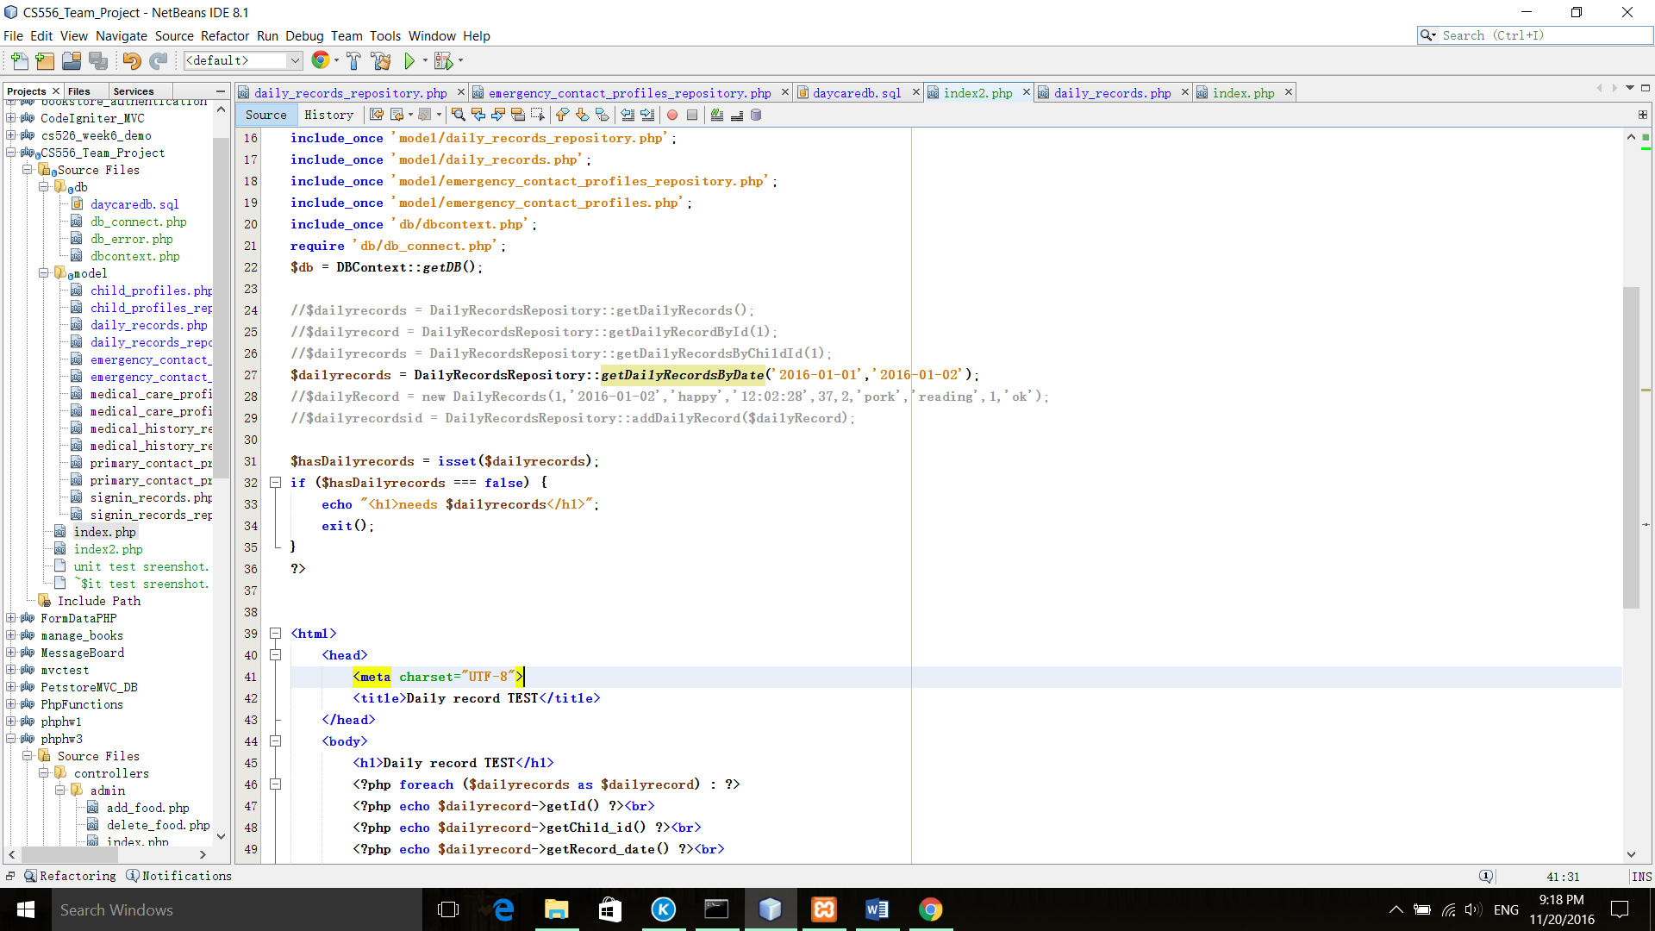

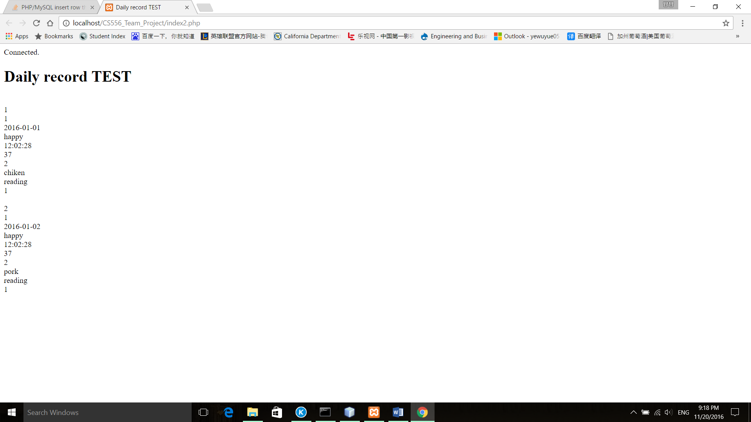

Test DailyRecordsRepository::deleteDailyRecordById($id)

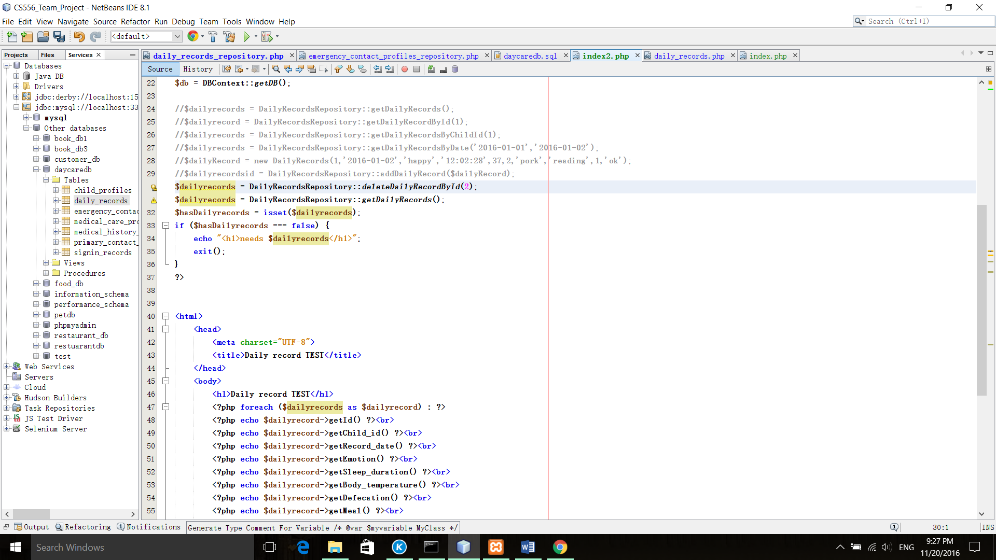

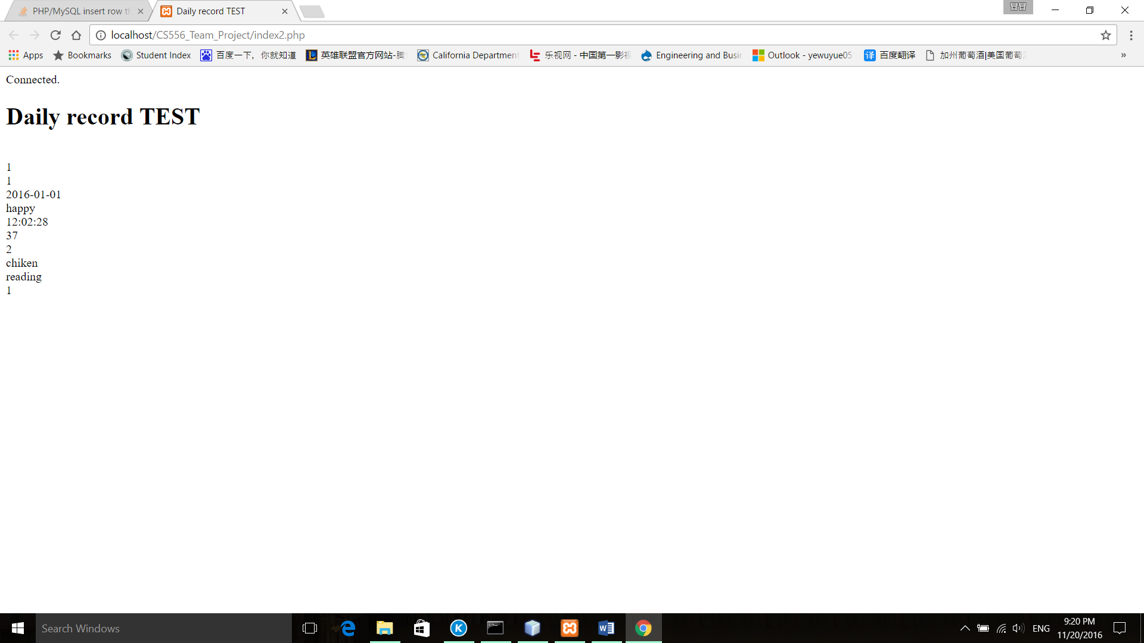

Test EmergencyContactProfilesRepository::getEmergencyContactProfiles()

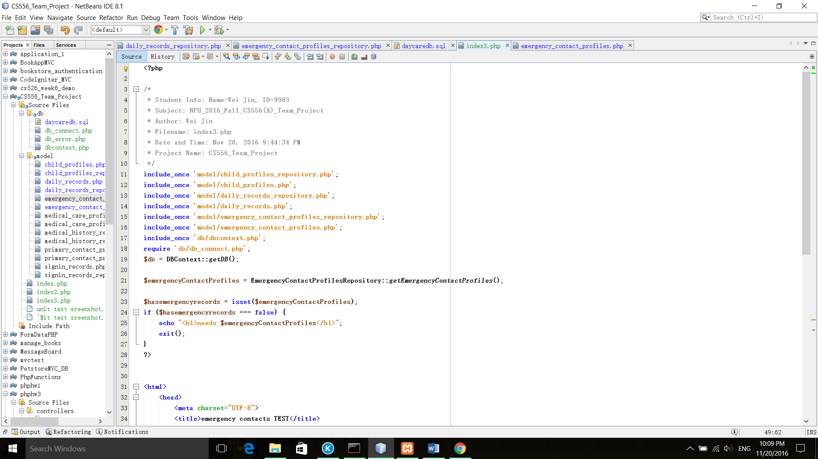

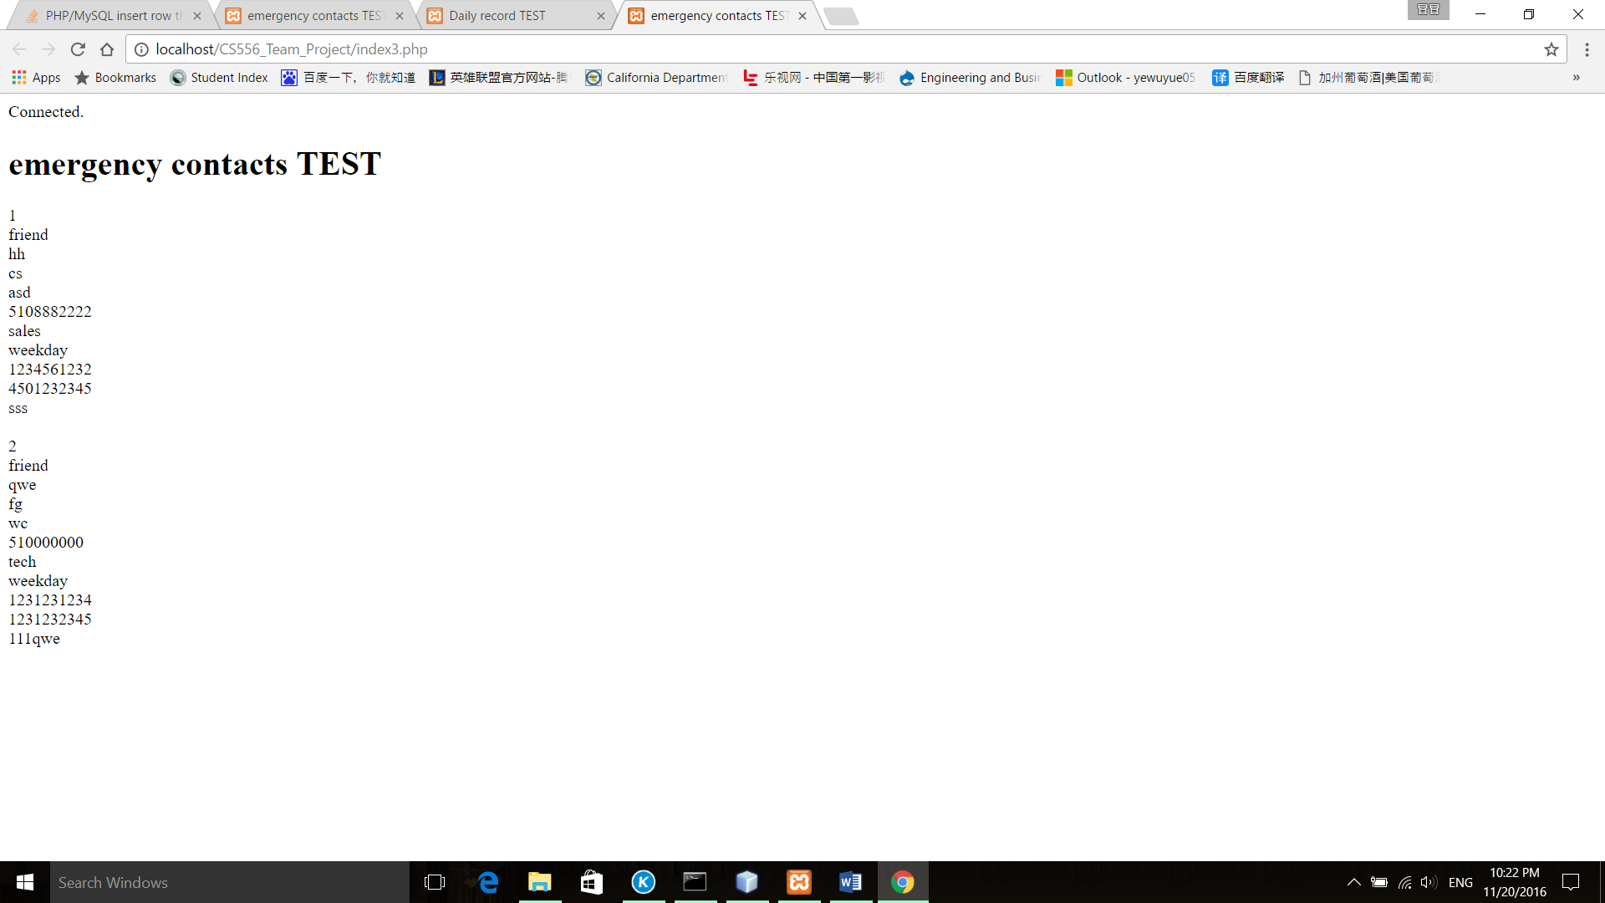

Test EmergencyContactProfilesRepository::getEmergencyContactProfileById($id)

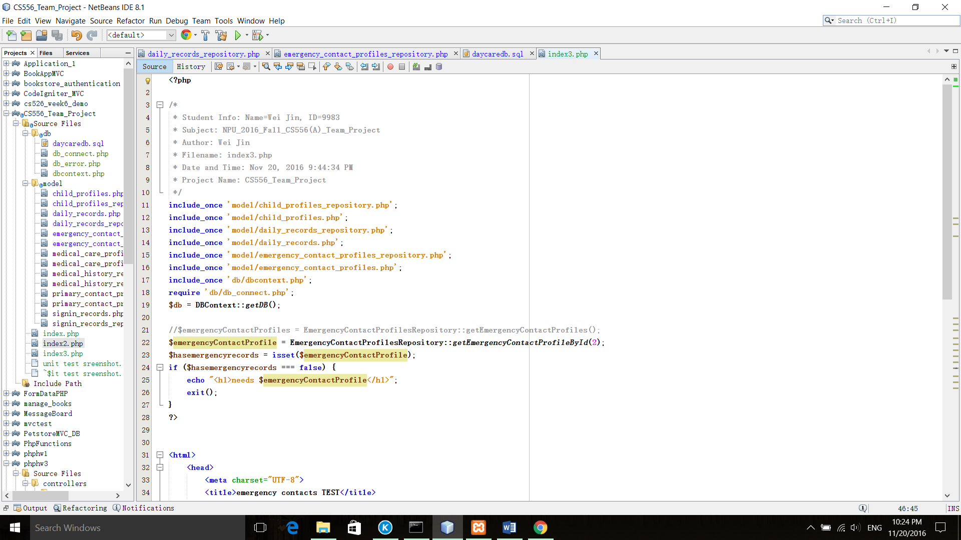

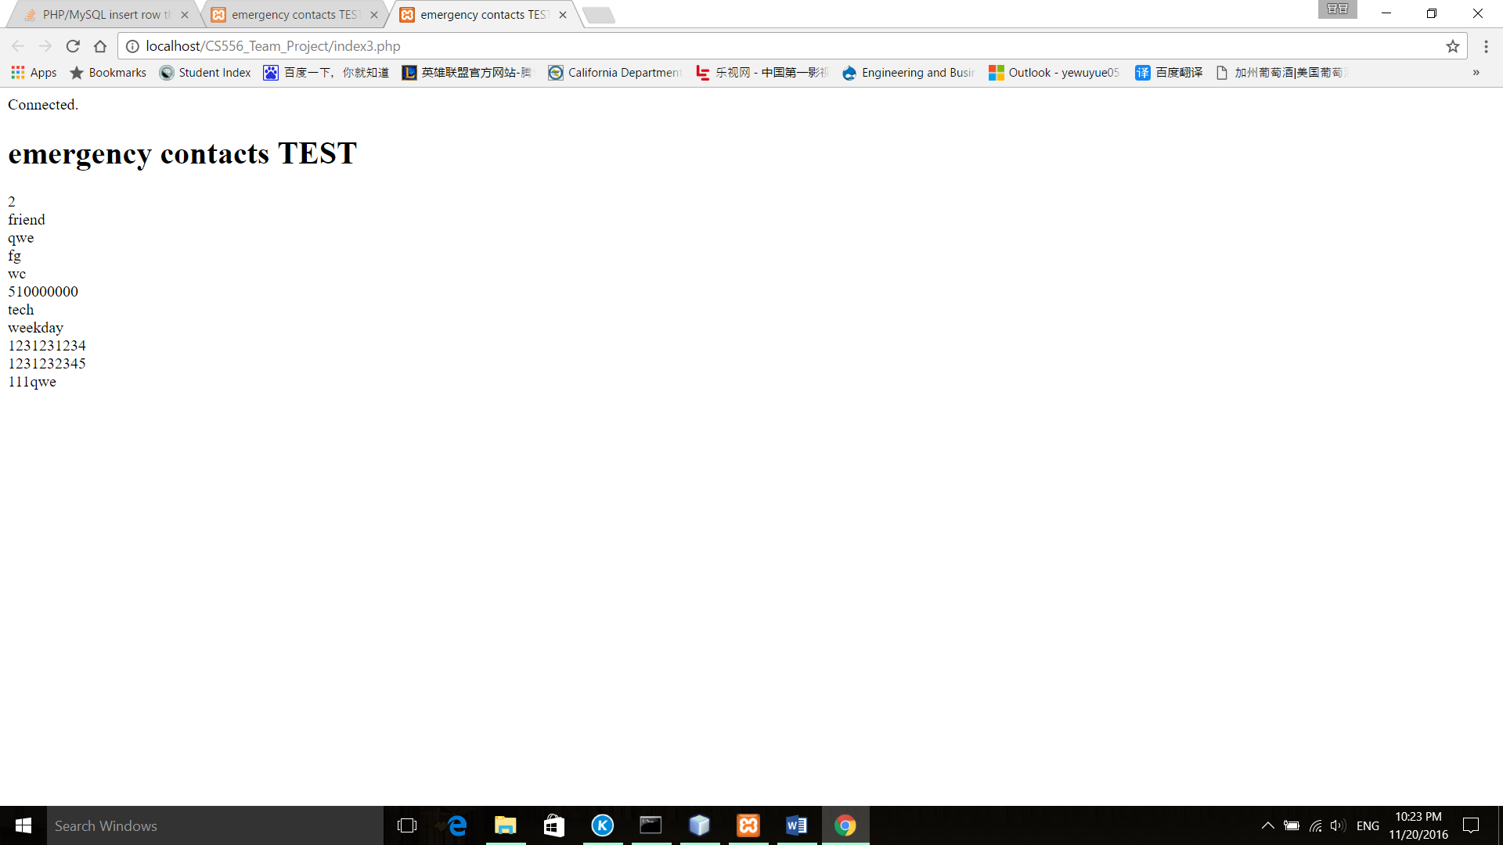

Test EmergencyContactProfilesRepository::getEmergencyContactProfilesByChildId($childId)

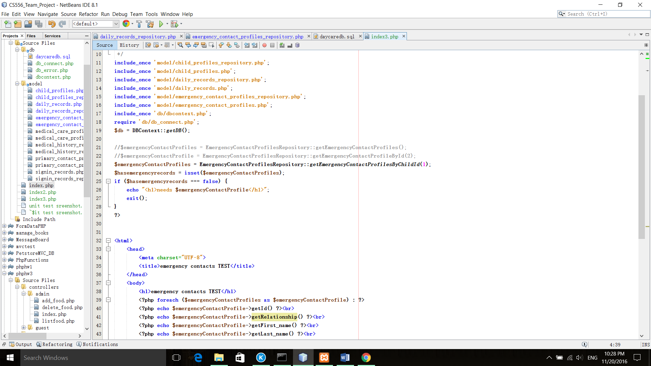

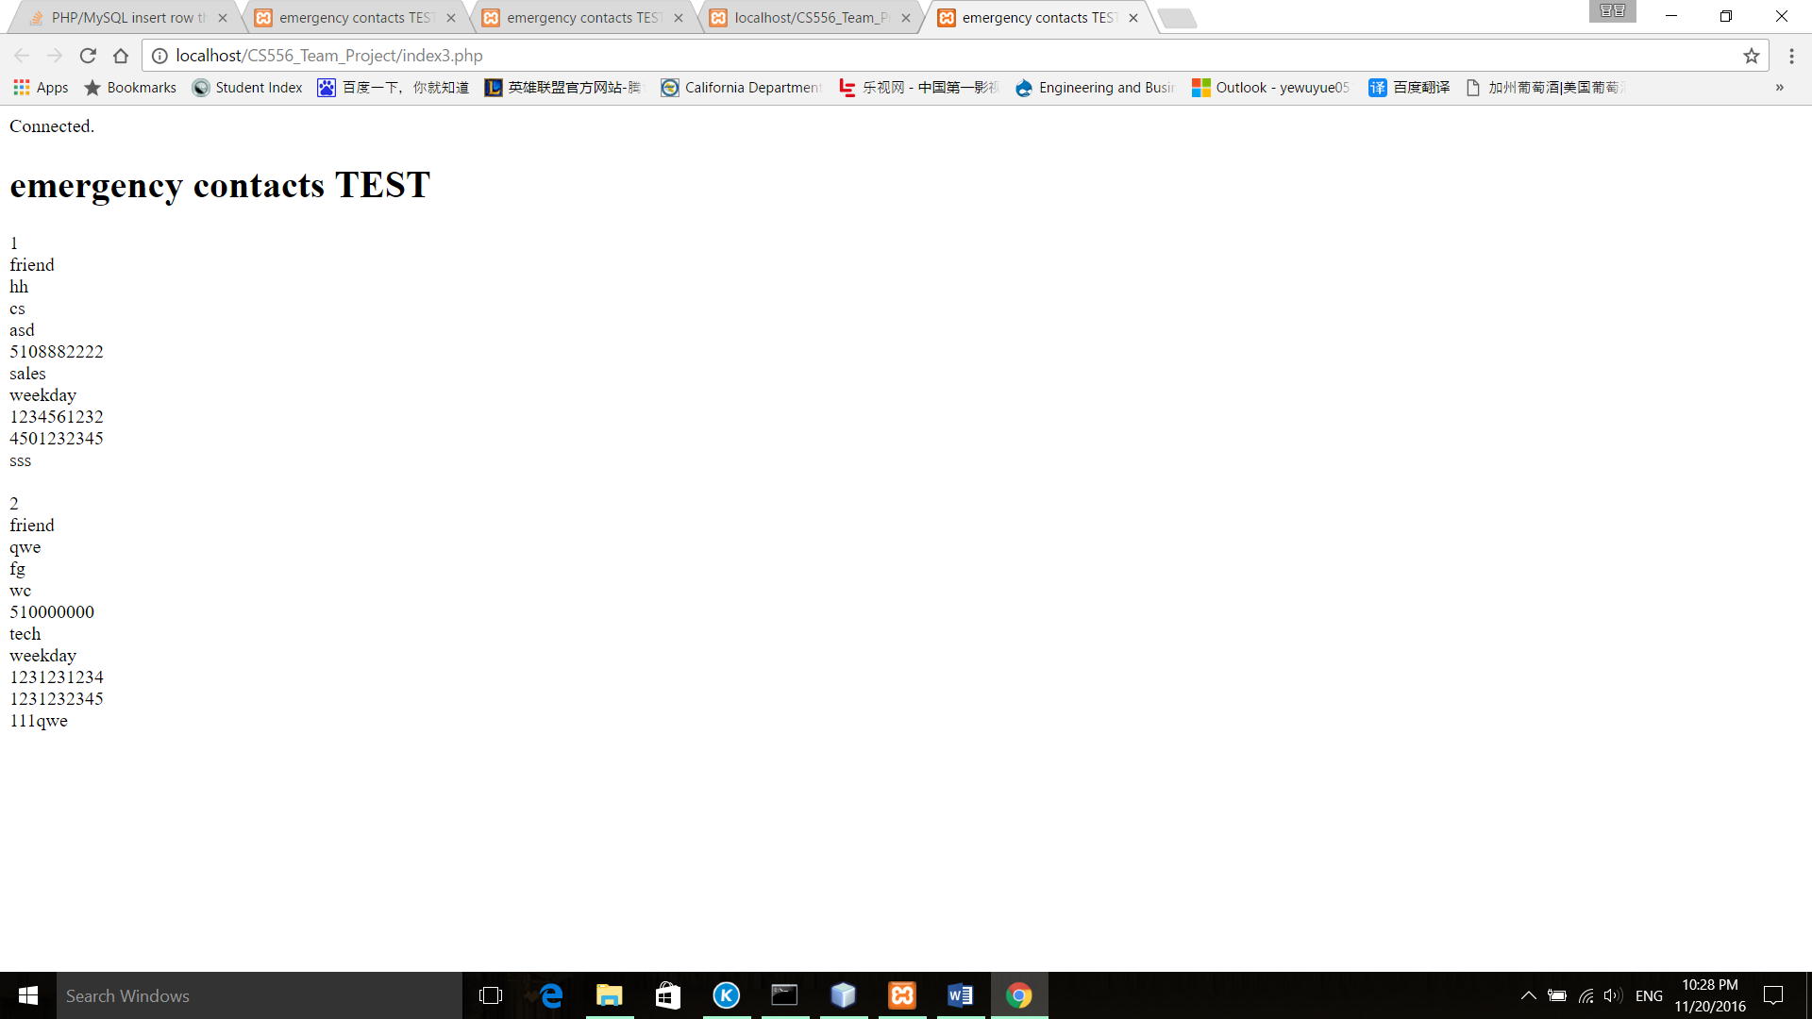

Test EmergencyContactProfilesRepository::addEmergencyContactProfile($emergencyContactProfile)

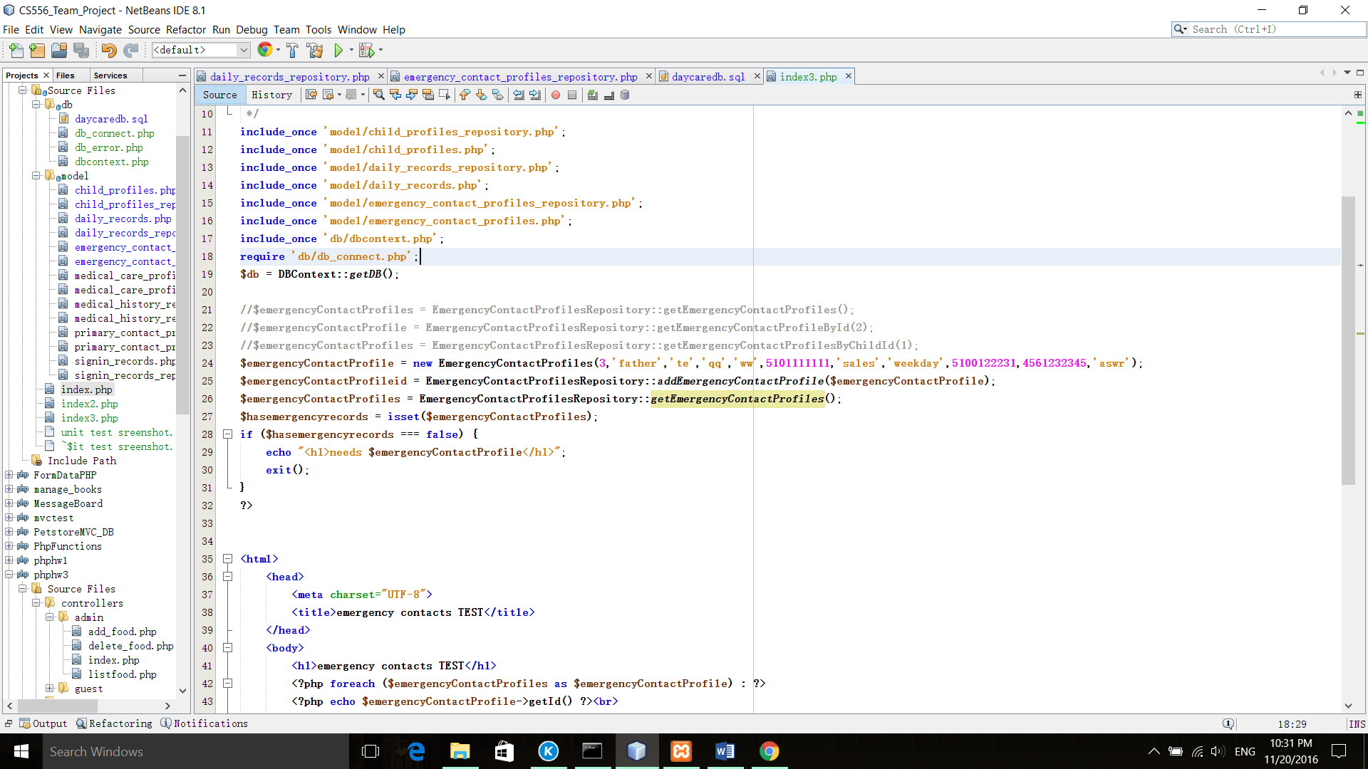

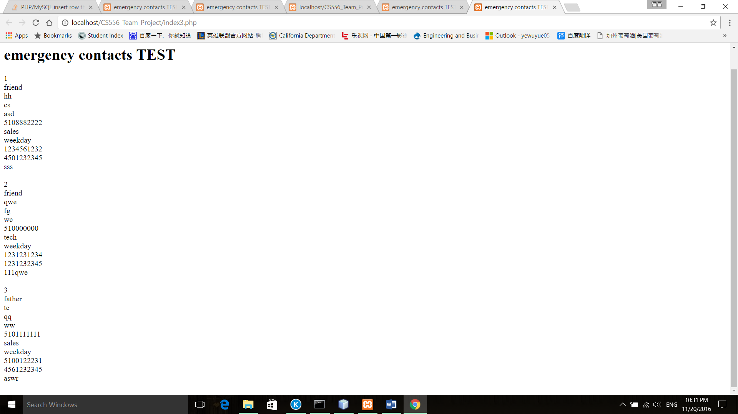

Test EmergencyContactProfilesRepository::deleteEmergencyContactProfileById($id)

